

**Applied Physics for**

**Scientists and**

**Engineers**

**Lab Report: To Study Angle of Dip by Earth Inductor:**

**Submitted to**

Sir. Haseen Ullah Jan

**Submitted by**

Muhammad Sadeeq Roll No.75025

Computer Systems Engineering

FALL 2021

Sec. C

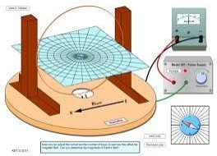

**Introduction & Background**

The earth inductor is a coil that is rotated through 180-deg through the earth's magnetic ﬁeld. The voltage induced voltage is measured as a function of time, the area under the curve is calculated. This can be used to calculate the magnetic ﬁeld. The coil can be positioned to measure the horizontal, vertical or total magnetic ﬁeld B.



**Analysis Method:**

**Apparatus:**

The following apparatus is used to carry out this demonstration:

1. Earth Inductor
2. Ballistic Galvanometer
3. Compass Needles
4. Magnetic

**Procedure:**

Following procedure is followed;

1. Connections are made as shown in the ﬁgure.
2. Key is pressed to damp the ballistic

galvanometer.

1. Galvanometer is calibrated.
2. Resistance is taken out from H.R.B.
3. Earth inductor is placed vertically with

earth’s lines of force.

6. Again, Earth inductor is placed

Horizontal with earth’s lines of force to

take ballistic galvanometer readings.

7. Hv and Hh give angle of dip by the formula,

**TanӨ=**

*HV*

*Hh*

1

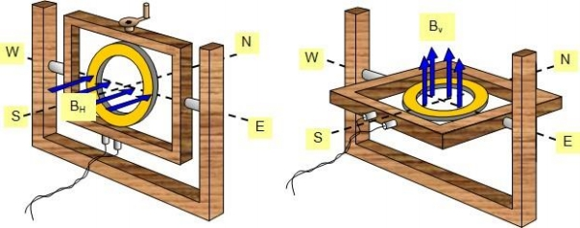

**Calculations:**

|  |  |  |  |  |
| --- | --- | --- | --- | --- |
| S.No. | Hv | Hh | Hv/Hh | **Ө=** *tan*−1 *HV*  *Hh* |
| 1 | 65 | 55 | 65/55 =1.1818 | 61.18 |
| 2 | 60 | 45 | 60/45 =1.333 | 53.123 |
| 3 | 30 | 35 | 30/35 =0.857 | 40.596 |
| 4 | 75 | 40 | 75/40 =1.875 | 61.927 |
| 5 | 37 | 30 | 1.23 | 50.96 |
| 6 | 39 | 32 | 1.21 | 50.63 |

Average **Ө=53.064**



**Precautions:**

Following precautions should be taken for this analytical experiment:

1. Earth inductor should be rotated a full 180 degrees for exact and accurate measuring.
2. Connections should be snug and rust free.
3. Ballistic galvanometer should be calibrated ﬁrst.
4. Key should be placed in contact after each reading for calibrating again.